Lab 1: The price of one request
Student: Akim Lunara
Course: AI CSS4007-ENG-5
- Prediction from Part1 and measured values
Tokenizers are typically trained primarily on English text, so they handle Russian better than Kazakh. Consequently, Russian text results in fewer tokens than the raw byte count would suggest, whereas Kazakh—which includes rare characters like ә, ғ, қ, ң, ө, ұ, ү, һ, and і—likely yields an equal or greater number of tokens. English text averages about one token per four characters, or roughly 1.3 tokens per word. For Russian and Kazakh, one generally expects 1.5 to 3 times as many tokens as for English, depending on the specific tokenizer.
COMPLAINT
------------------------------------------------------------------
EN RU KK
chars 300 315 344
bytes 300 576 640
words 54 45 42
bytes/EN 1.00x 1.92x 2.13x
bytes/char 1.00 1.83 1.86
counting tokens on gemini-3-flash-preview (free, no model run)
sentence en=13 ru=18 kk=31
complaint en=60 ru=79 kk=149
system_prompt en=41 ru=52 kk=88
request en=101 ru=131 kk=237

RU / EN - 79 / 60 = 1.32x
KK / EN - 149 / 60 = 2.48x

- Table of annual cost

AT 2,000 REQUESTS/DAY -- US dollars per year
------------------------------------------------------------------------
EN RU KK
flash-lite-3.1 1,344 971 1,333
flash-3 2,689 1,942 2,666
pro-3.1 10,756 7,769 10,665

AT 5,000 REQUESTS/DAY -- US dollars per year
------------------------------------------------------------------------
EN RU KK
flash-lite-3.1 3,361 2,428 3,333
flash-3 6,722 4,855 6,666
pro-3.1 26,890 19,422 26,663
5,000 requests per day represents a high-volume support queue, so the annual cost shows how token usage and model choice can affect the budget at production scale.
- Which model for Kazakh languages
Based on the quality of the responses and the pricing, I would choose the Flash Light 3.1 model; the cost is reasonable, and I liked the way the query was handled—there was no guesswork involved. Instead, the representative asked the client to try a few potentially helpful steps and advised them to contact the bank or provide the missing information needed to resolve the issue if those steps didn't work.
- Suggestions
Limit the response length and the "thinking" budget, because output tokens account for almost the entire cost; system prompt caching reduces only the small input portion.
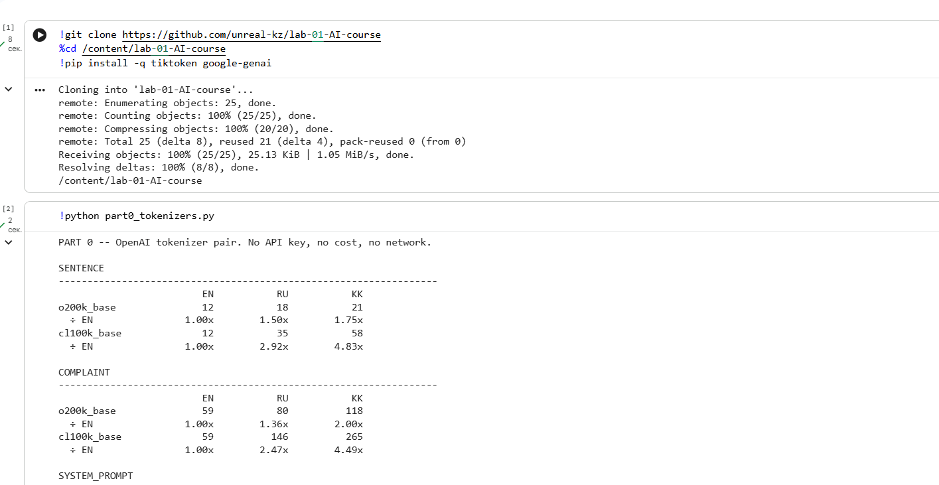
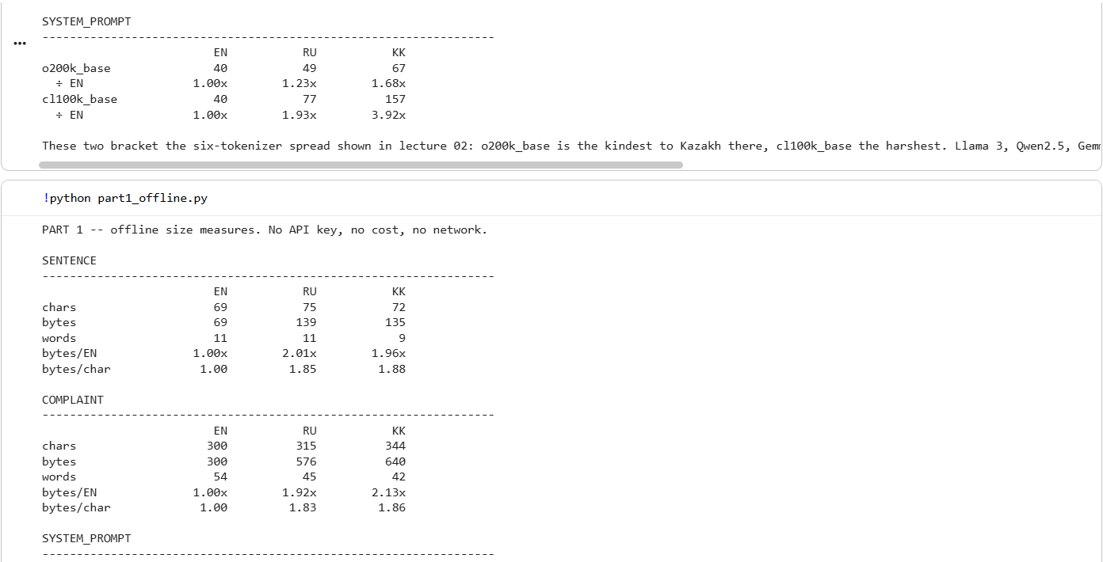
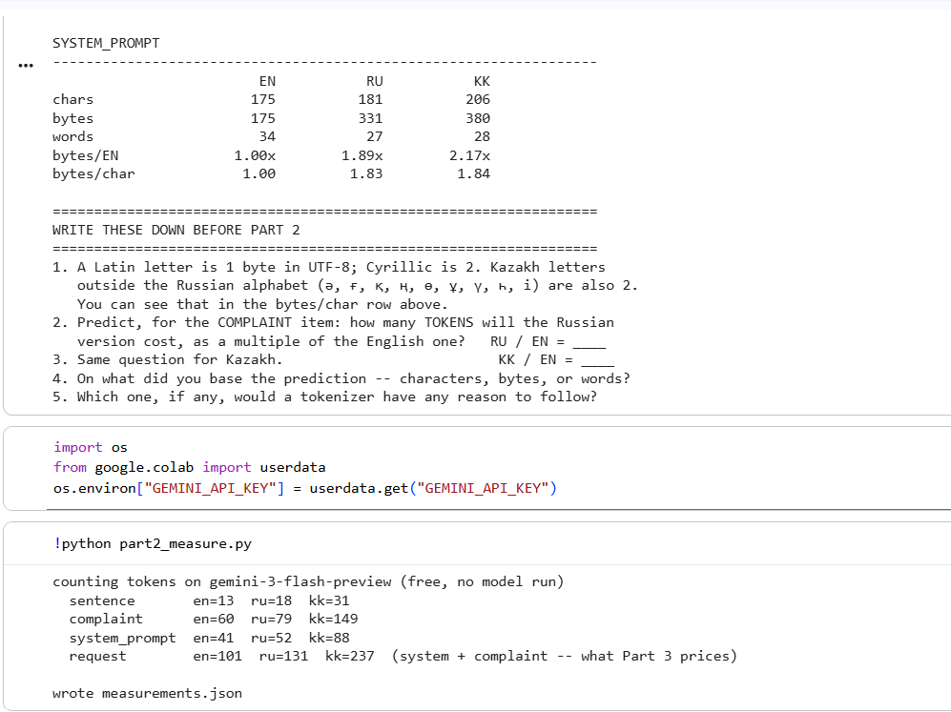
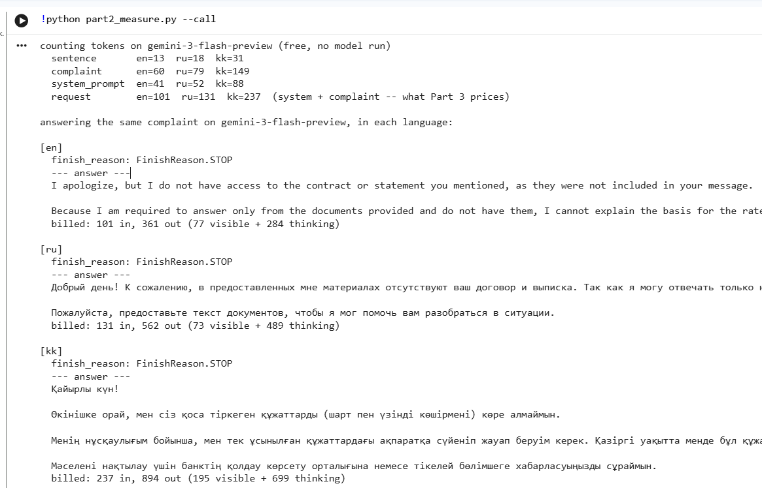
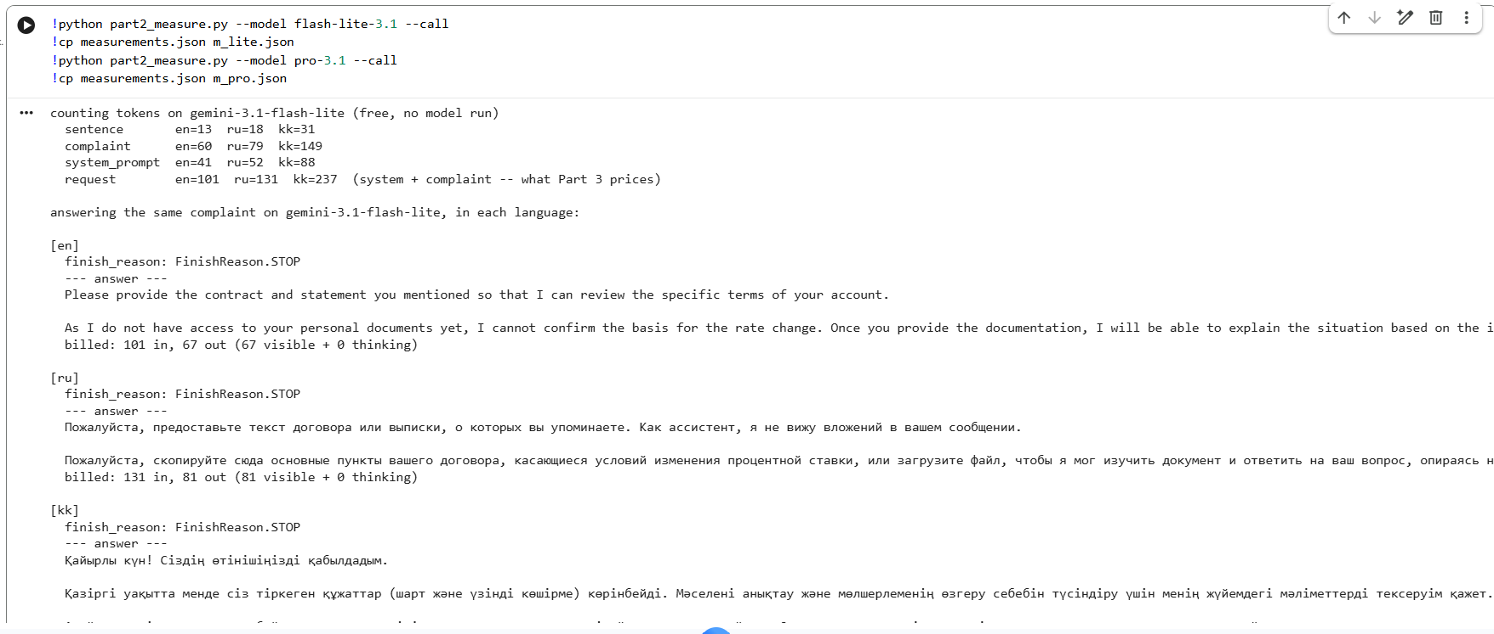
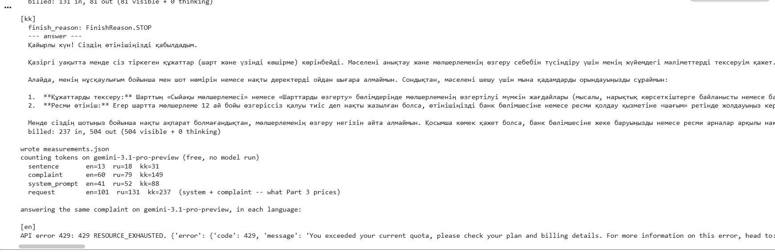
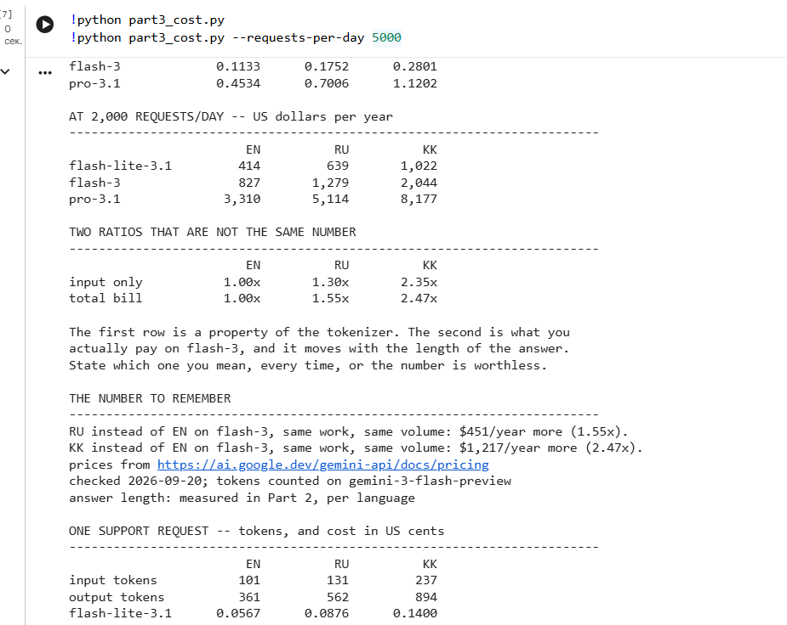
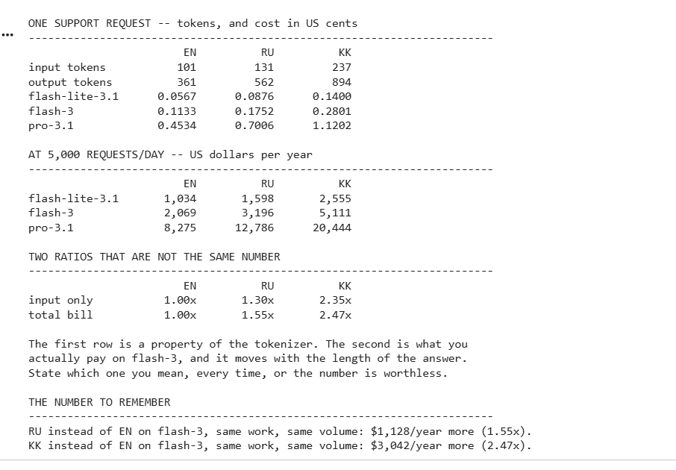
Declaration of using AI
I primarily used Claude AI to understand the workflow and the steps required to obtain an API key. Claude explained that the Anthropic API key is a paid service, so it suggested using Gemini and working in Google Colab for convenience, noting that the entire setup operates within the Google ecosystem. It also proposed using the terminal as an alternative; however, since I successfully generated the correct outputs and the code ran properly, I completed everything in Google Colab. Claude also helped adapt the code for Gemini AI. We modified the code in the "part2," "part3," and "price" files, as well as the data in the "text" file; Claude provided the pricing figures, which I verified against the official website (ai.google.dev/gemini-api/docs/pricing). During execution, I encountered 400, 503, and 429 errors; Claude helped me understand what these errors meant and resolve the 400 error by using an API key from my personal Google account instead of a corporate one.

